**DM lite 4K Precautions when using**

1.Account login and logout must be connected to the Internet.

2.The position of the chip and the electrode should correspond, and the corresponding relationship is shown in the figure below

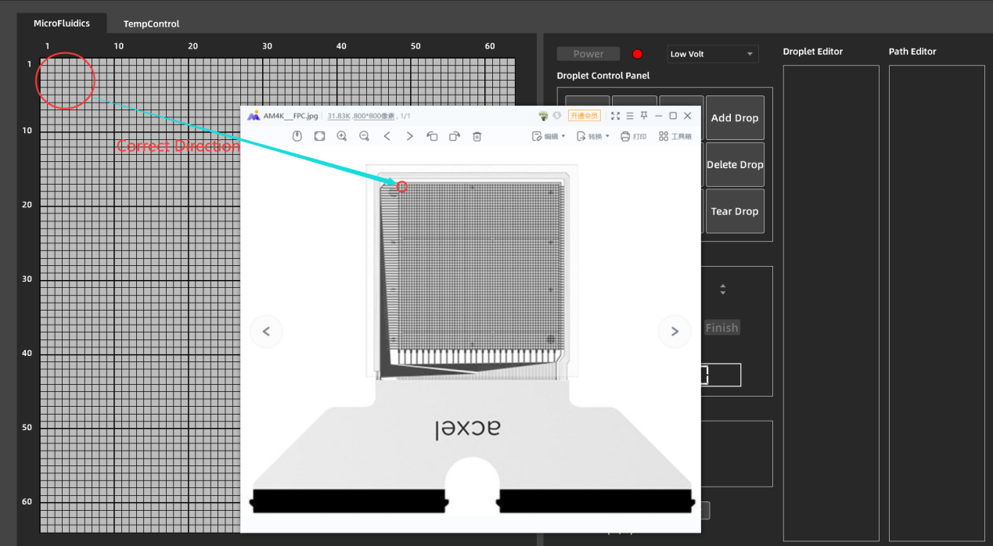

3.The power on area should be near the liquid injection hole, about 2-3 rows away. If you add a power on area by importing a path, double-click the path to generate the corresponding power on area (the power on area and path overlap), and then right-click the generated power on area to move freely.

4.The reagent in the pipette should be larger than the volume of the power-on area (the volume of one electrode on the chip is 25nl). When the liquid is successfully injected, the regular shape of the same as the power-on area will be formed, and the excess reagent will automatically overflow when the gun head is loosened.